

Getting started

**National College of Ireland**

**Team Project Proposal**

**<Academic Year 2023/2024>**

**<Eskandar>, <23137517>, <x23137517@student.ncirl.ie>**

**<Alex>, <22440482>, <x22440482@student.ncirl.ie>**

**<Joshua>, <23153920>, <x23153920@student.ncirl.ie>**

**<Yonas>, <23154454>,** [**x23154454@student.ncirl.ie**](mailto:x23154454@student.ncirl.ie)

**Note: Each student will do their part, the parts will be decided accordingly can be seen via** [**GitHub commits**](https://github.com/EskandarAtrakchi/Market-Live-Prices-Team-Project/graphs/contributors)**.**

**Note: to access the repo click** [here.](https://github.com/EskandarAtrakchi/Market-Live-Prices-Team-Project/graphs/contributors)

**Note: for better mock-ups representations please read this proposal on Git-Book** [**here**](https://eskandar-atrakchi.gitbook.io/team-project-proposal/mock-ups/icons)

Contents

1.0 Overview 2

Brand Guidelines 2

🧱 Foundations 2

🛠 How we build 2

Other functionalities 2

Accessibility 2

Overview Sketch Pad Idea 3

2.0 Target Group 3

3.0 Functionality 3

4.0 Mock-Ups 5

Mock-Ups Sketchings 5

5.0 Timelines 8

6.0 Summary 8

# Overview

## Brand Guidelines

## 🧱 Foundations

Our brand foundation is inextricably linked to the emotional and functional of the people towards the crypto market, out website is allowing people from different parts of the world to retrieve the price of any crypto coin or token in the crypto market in the real time as well as knowing the whole crypto market condition.

## 🛠 How we build

We build with the latest and the most trusted available technology as we get in to the conclusion of using node.js as a back-end server for out project and displaying the JSON content in a dynamic chart using chart.js technology for the front-end.

## Other functionalities

The project will have a chat channels that people from around the world can chat in different channels, this will open the door for the real world people encagements as not only checking the prices but posting and reading people's opinions.

​

## Accessibility

**Good to know:** Accessible design lets people of all abilities interact with, understand, and navigate our product.

Accessibility means that people are empowered, can be independent, and will not be frustrated by something that is poorly designed or implemented.

Here at our product, we comply with all levels of accessibility, to put it in a different words all people from anywhere on earth can access our website and make use of the services that we provide.

Our project is different than what exists in the market as it should provide more services, all in one product for different people with different special needs such as blind color people.

We have explained what colors, typography, and resources we will use in the [Mock-Ups section](https://eskandar-atrakchi.gitbook.io/team-project-proposal/mock-ups/icons).

## Overview Sketch Pad Idea

Overview of the sketch pad idea, This sketch pad can be found on [GitHub](https://github.com/EskandarAtrakchi/Market-Live-Prices-Team-Project/blob/main/SketchPad_BusE_page-0001.jpg) or [Gitbook](https://eskandar-atrakchi.gitbook.io/team-project-proposal/overview/overview-sketch-pad-idea)

# Target Group

There are over 425 million cryptocurrency users worldwide [(Statista)](https://explodingtopics.com/blog/cryptocurrency-stats)

Crypto's worldwide market capitalization was estimated at $US1. 09 trillion as of August 2023 [(CoinMarketCap)](https://www.forbes.com/advisor/au/investing/cryptocurrency/cryptocurrency-statistics/)

That means there is a big market for crypto and there is big money out there.

The targeted audience from our website is anyone who are interested in crypto market regardless their language, geographical location, and their level of education.

Likewise anyone who wants to use crypto to buy or sell various products without the bank or government monitoring your transactions, which can prevent account freezes.

The numbers of the crypto market can be understood in any language!

# Functionality

* • The website can retrieve any cryptocurrency price in real time and can display to the users the following a. Symbol of the currency b. ID c. Price (US-Dollar) d. 24 h Volume (US-Dollar) e. Market Capitalization (US-Dollar) f. Percent Change (1h) g. Percent Change (24h) h. Percent Change (7d) This is extremely important if the user wants to know the volatile price of some specific currencies.
* • Fear and Greed index of the whole crypto market indicates if most of the traders are buying or selling, the index is calculated from 0 to 100. Zero means "Extreme Fear", while 100 means "Extreme Greed"
* • The ID number retrieval for any cryptocurrency that exists in the crypto market, the API will retrieve the ID number of the cryptocurrency, and the reason for this is because the smaller the ID number of the cryptocurrency the more data about the prices of the currency that we have. example on that is Bitcoin (BTC)
* • Users can chat and read other people's chats in different terminals.

# Mock-Ups

## Mock-Ups Sketchings

​

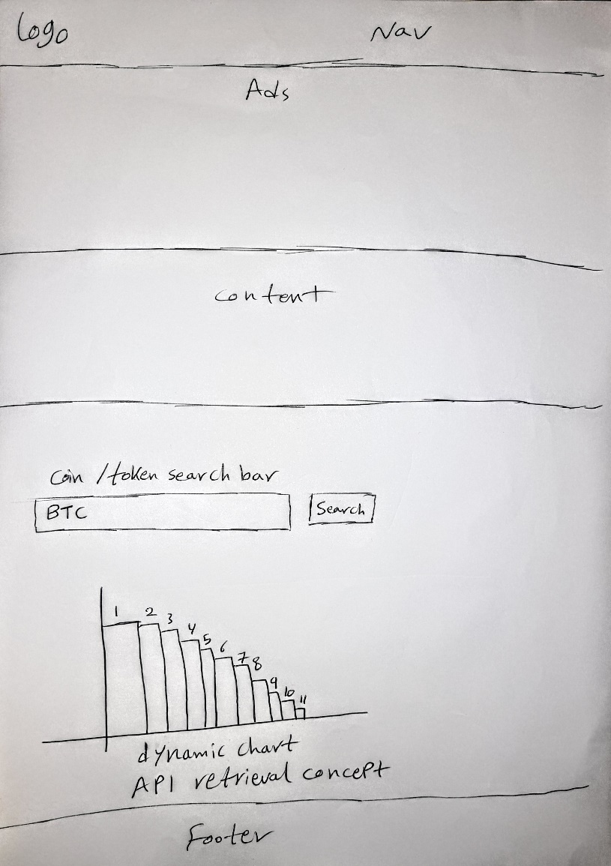

Listings retrievals via API

Listings retrieval API, by typing the name of the cryptocurrency the chart of all similar names should pop up with an interactive dynamic chart.

​

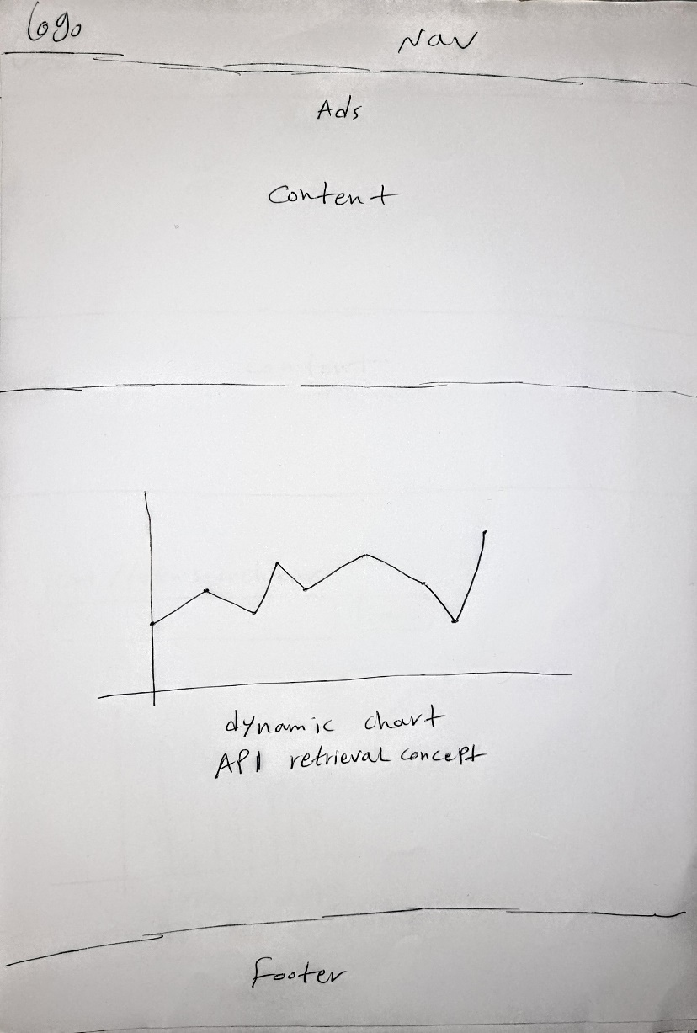

Dynamic charts via API

crypto market condition via API calls, dynamic chart should pop up.

​

Terminals for chats

People can chat and drop their opinions here; anyone can chat via terminals.

Note: For better representation of the mock ups is available on the proposed document on GitHub [here](https://eskandar-atrakchi.gitbook.io/team-project-proposal/mock-ups/icons)

# Timelines

**Good to know:** That the team is using GitHub to document its process and we decided on agile methodology, however, we have planned a timeline using gantt chart to merge agile and waterfall methodologies and preform our best to get better results.

|  |  |
| --- | --- |
| **Project proposal** | **Week 2** |
| **Requirements specification** | Week 4 |
| Peer review (during class) | Week 5 |
| **Mid-point submission** | Week 6 |
| Mid-point presentations (during class) | Week 7 |
| Peer review (during class) | Week 10 |
| **Final submission** | Week 12 |
| Final presentations (during class) | Week 14 |

This is the timeline constrains and we will follow accordingly.

# Summary

In conclusion, the website is accessible online by anyone interested in the crypto market, prices, volume, market cap, and the fear and greed index of the whole crypto market.

Dynamic charts and interactive will be used so the user can check the old data of a specific coin or token, this functionality will make people spend more time on the website.

Chat terminals will be useful for people to chat, give their opinions about the crypto market, and read other people's opinions, this will create engagement on the website.